

Linnaeus University

1DV532 – Starting out with Java

Assignment 2 Report

Student: Evan Huynh

Student ID: eh223im@student.lnu.se

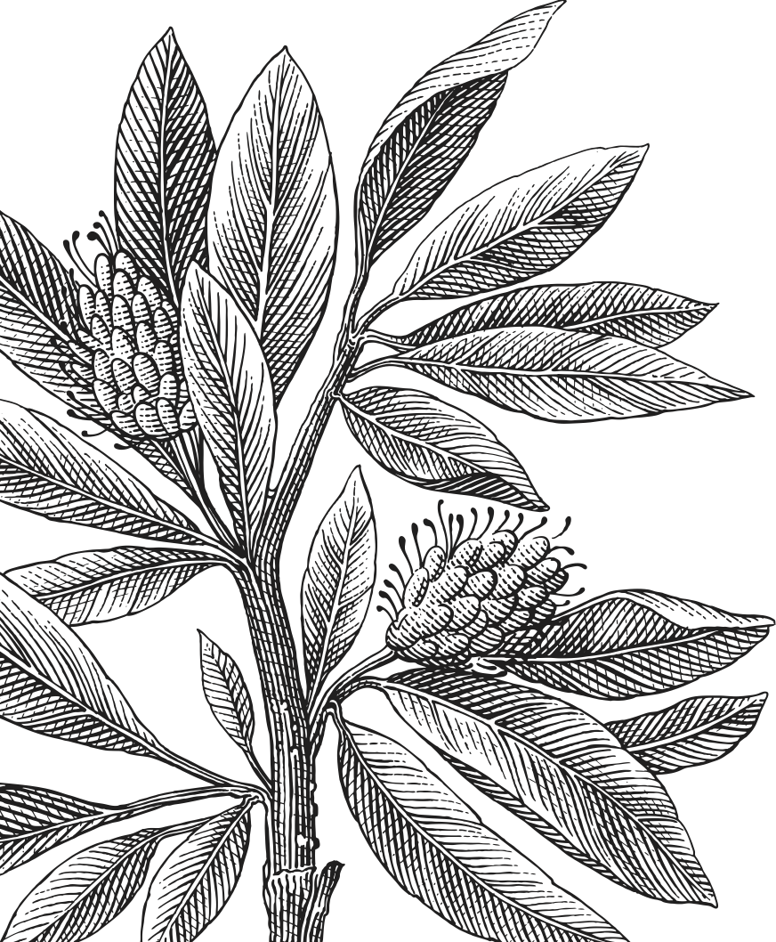

Table of Contents

Report 3

Exercise 1: Int 3

Idea 3

Exercise 2: SweID 3

Exercise 3: Pizza 3

Exercise 4: Money 3

Source code 3

Bibliography 3

# Report

## Exercise 1: Int

The exercise requires basic arithmetic for two integers in “Int” type.

## Exercise 2: SweID

This exercise contains lots of static classes for Swedish ID and checkers.

## Exercise 3: Pizza

This exercise

## Exercise 4: Money

Similar to exercise 4.

# Source code

Here is my source code for all the exercise.

|  |
| --- |
| 1 |
|  |
| 2 |
|  |
| 3 |
|  |
| 4 |
|  |

# Bibliography

**Invalid source specified.**